Day 31: Distributing your Android App and Wrap-up

Before we wrap up, let’s take a quick look at how we can distribute a Xamarin.Android Application. The most common way to distribute your android application is using the Google Play Store. To distribute an app on the Google Play Store, we need to create an “APK” file. Let’s take a look at how we can do that from Xamarin Studio –

In Xamarin Studio, make sure you switch your Configuration to “Release” mode.

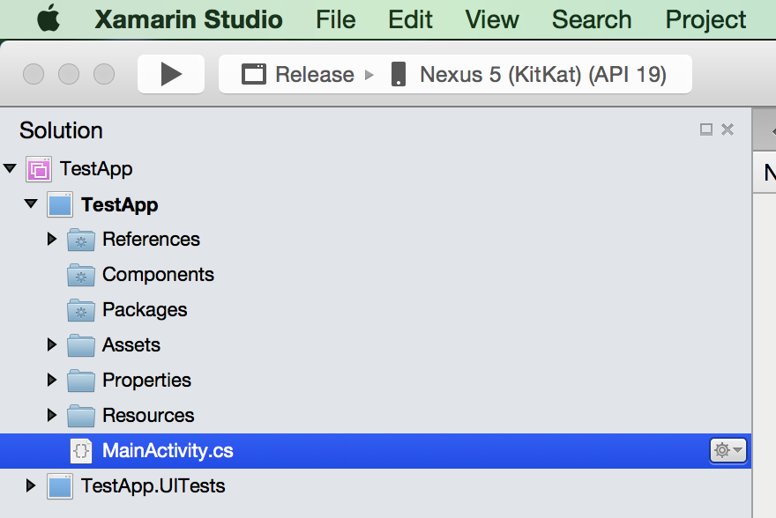

After that, click on “Build” menu option and then click on “Archive for Publishing”. You will then be building your android application and once it’s done, you will see the results in a “Archives” window.

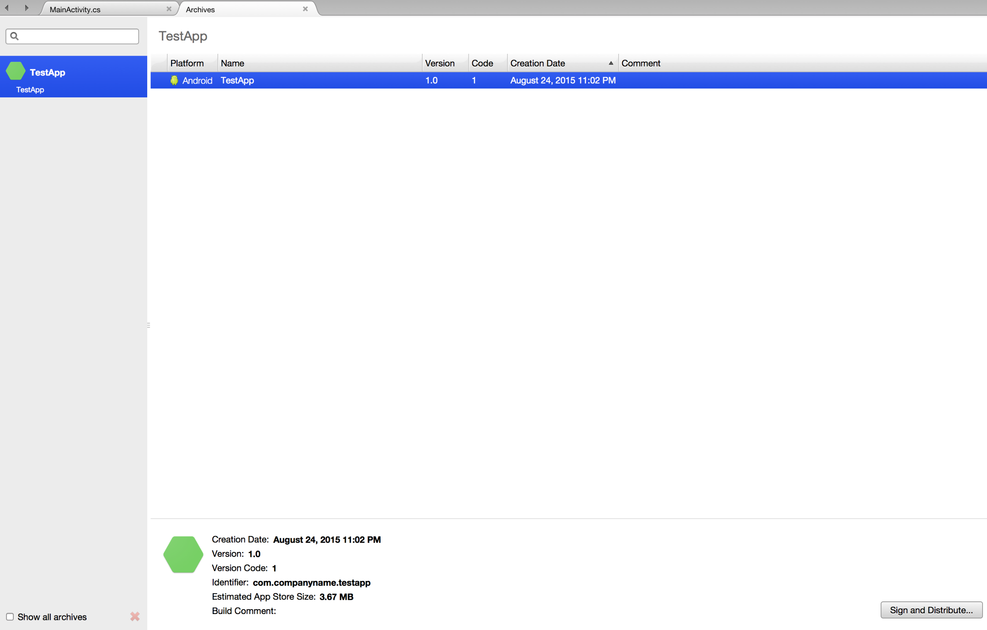

You now need to Sign your application. The Archives window has an option to “Sign and Distribute…” once you click that, you will be presented with “Sign and Distribute” dialog.

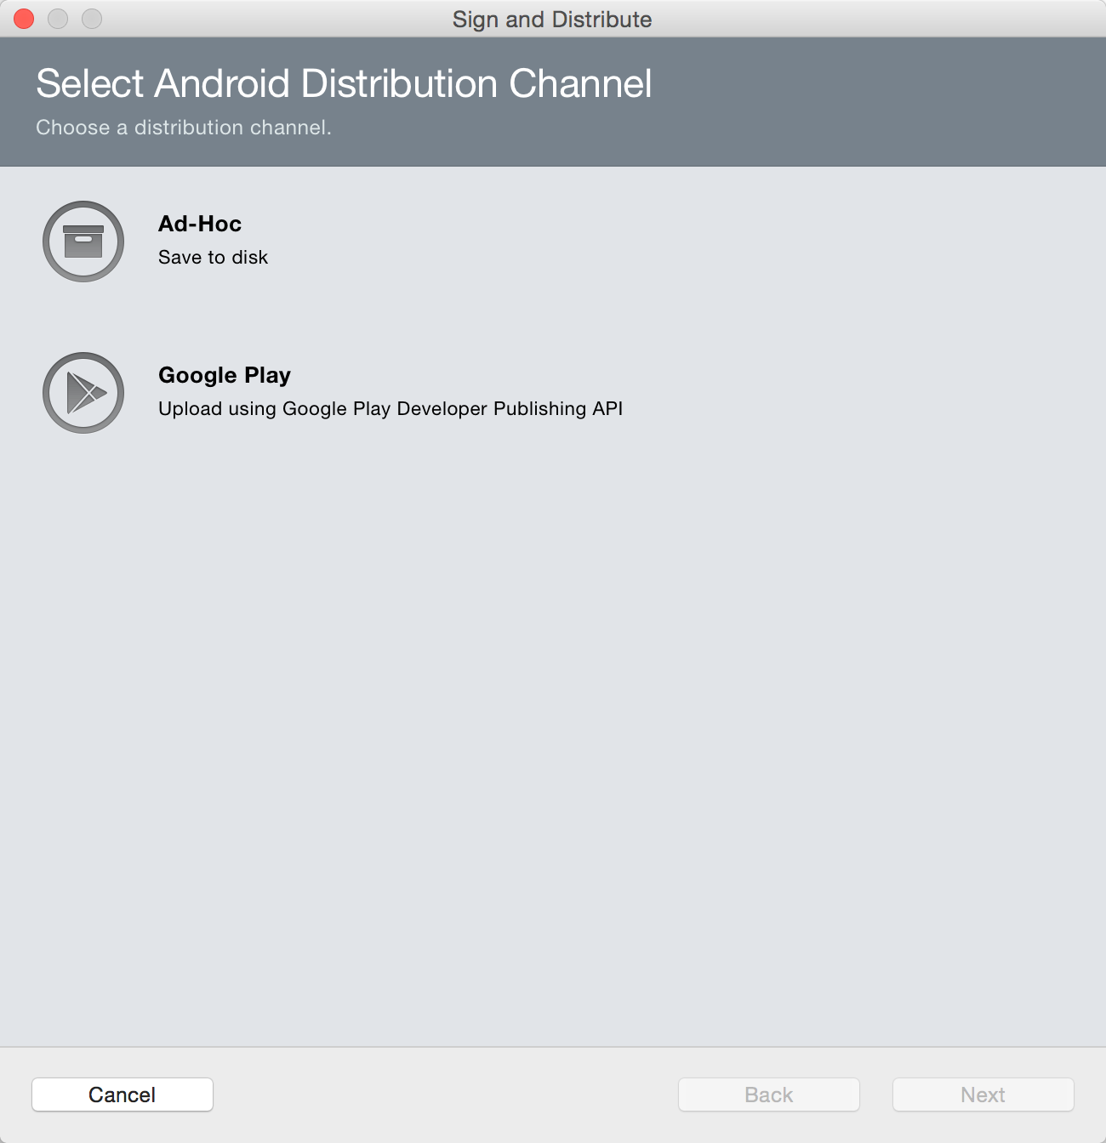

I generally pick “Ad-Hoc” here as this option just saves the APK to the disk and lets me even to upload to app distribution services like HockeyApp. Once you pick Ad-Hoc and hit next, you will be asked to Sign with a key –

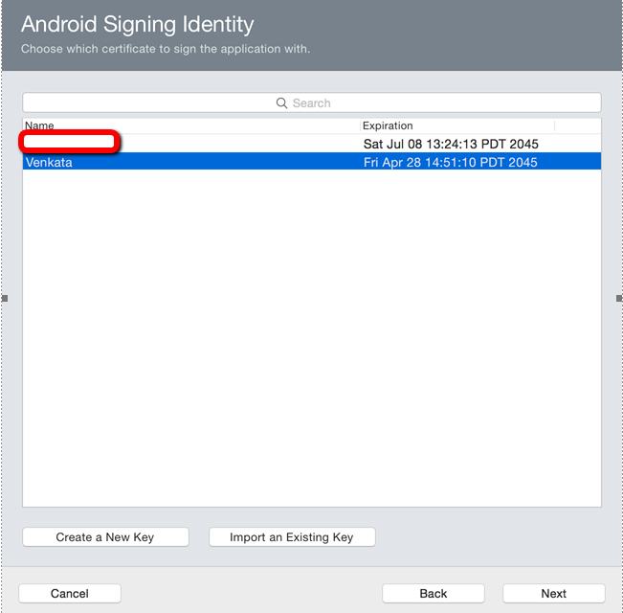

If you have an existing app, you need to use the existing key. If not, you can create a new key. Please hold on to the password for the key VERY carefully, as it is required to update you android application in the future. And once Signing is done, you can just save the APK file.

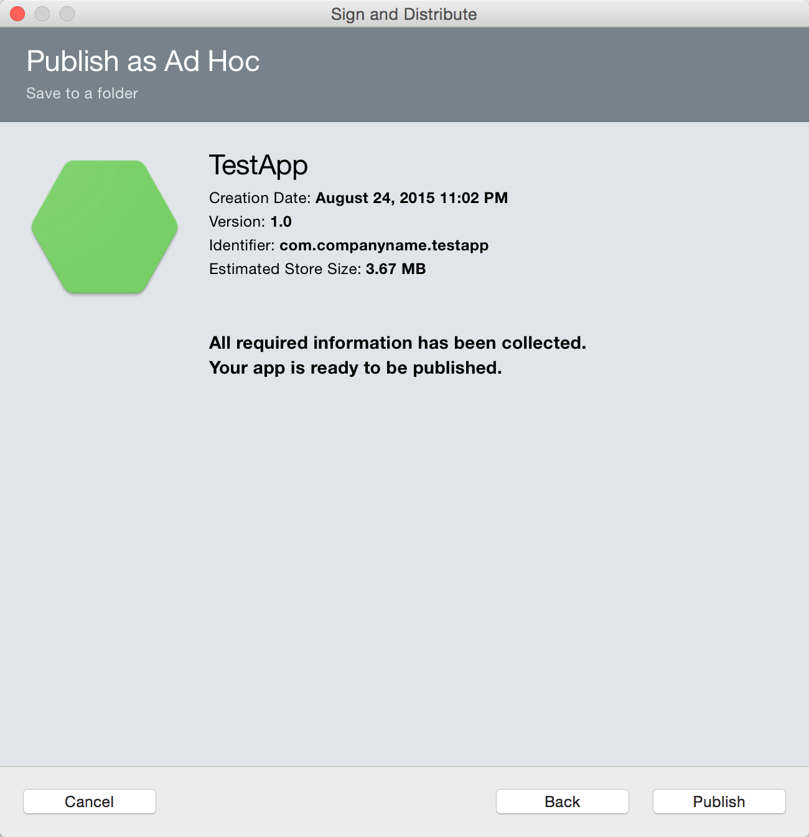

Where “Publish” prompts us for a location to save the file in

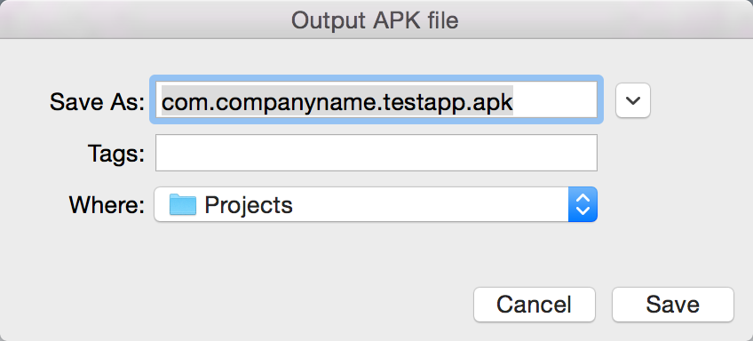

You will also be asked for password for the selected signing certificate if you are reusing a certificate –

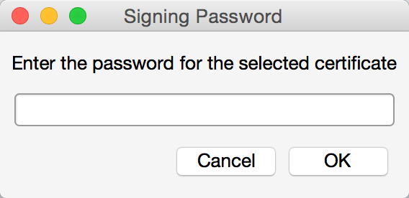

And voila, your APK to distribute on Google Play Store is ready

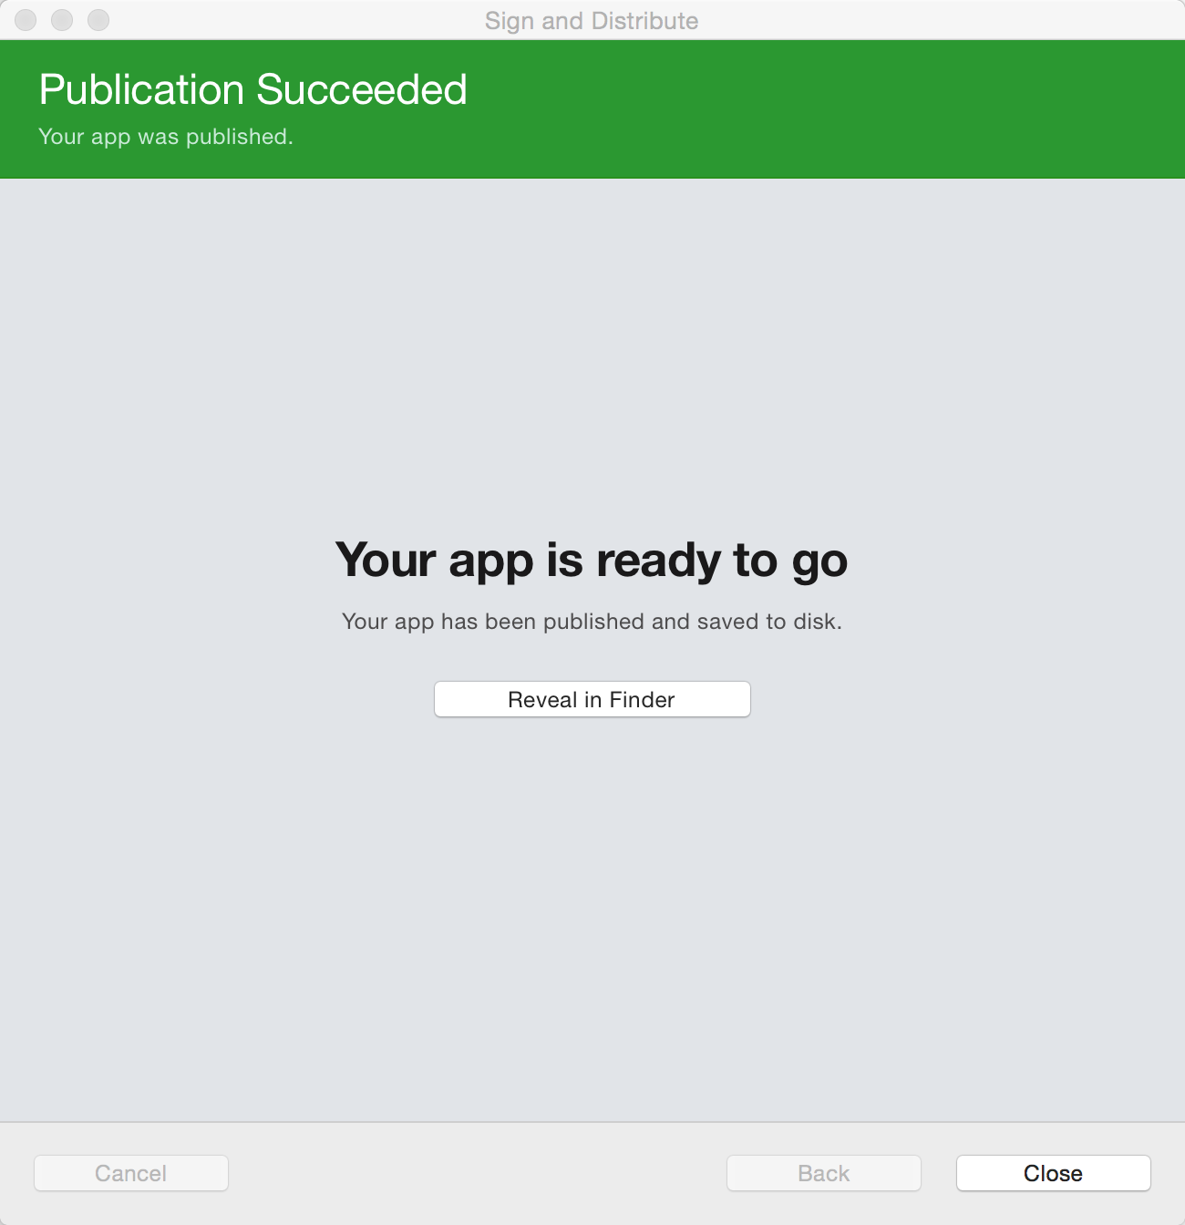

You can take this APK and go to the Google Play Developer Console and upload this APK on to the Play Store.

That brings me to end of this series of “31 Days of Xamarin Android”. I hope you all learned something from this series, I surely did learn a lot more just by writing about all the concepts. If you have any more articles you want to see and learn about Xamarin.Android, or for that matter Xamarin in general, feel free to let me know in the comments, or on twitter (@vkoppaka). I’d love to hear from you. I have more goodies coming to this blog like fully completed apps (spawned from the series) and more articles, so be sure to come back and read.